
SAMET ÖZGÜL
705201014
BBL536E Data Science
Homework-II Report

Problem 1

In this problem, we have two task that we need to do. But before perform that task, we should drop “Date” column. Also the data value’s type should be changed. It means, we should replace comma seperated values with dot seperated. Because comma seperated values are not convert to float when feed to model.

First task, I used SelectKBest method to find top-4 features having highest relationship with target. The SelectKBest method’s score function is selected as mutual information as given in question.

Second task, I used RFE method to find top-4 feature modeled with Ridge regressor.

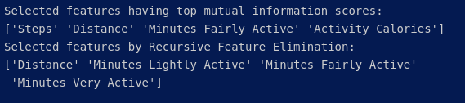
There are different methods to find feature importance in this problem. But It is clear to see, top-4 features almost same in different methods. If we want to select features, ‘Distance’, ‘Minutes Fairly Active’ should be selected. Because that features is in both results.

Problem 2

In this problem, we will investigate clustering with K-means algorithm. Firstly, we read data from file, after ‘ID’ column is dropped. Then we should scale data with StandartScaler.

To identify number of cluster, we can use two techniques which are elbow and shilhoutte. We will give different numbers (2 to 9) to K-means algorithm’s cluster number then we will get both elbow and shilhoutte coeffients.
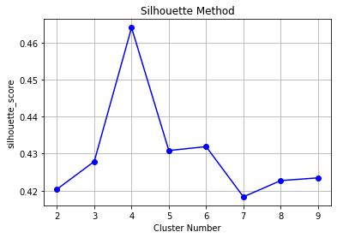
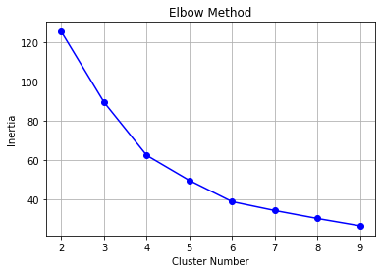

We can plot that coefficients to identify number of cluster. We have to select the value of k at the “elbow” ie the point after which the distortion/inertia start decreasing in a linear fashion. Thus for the given data, we conclude that the optimal number of clusters for the data is 4.

The value of the Silhouette score varies from -1 to 1. If the score is 1, the cluster is dense and well-separated than other clusters. A value near 0 represents overlapping clusters with samples very close to the decision boundary of the neighboring clusters. A negative score [-1, 0] indicates that the samples might have got assigned to the wrong clusters. The silhouette plot shows the that the silhouette coefficient was highest when k = 4, suggesting that's the optimal number of clusters.

Problem 3

